

ANTI BULLYING

POLICY
Armley Grange School 

CONTENTS PAGE

1.0 INTRODUCTION 2
2.0 POLICY STATEMENT 2
3.0 WHAT IS BULLYING BEHAVIOUR? 3
4.0 OUR APPROACH TO BULLYING 5
5.0 RESPONSIBILITIES 5
6.0 PREVENT BULLYING 5
7.0 INTERVENTION AND RESPONSE 6
8.0 MONITORING INCIDENTS 6
9.0 COMMUNICATING POLICY 7
10.0 PROCEDURES FOR PARENTS 7
11.0 PROCEDURES FOR PUPILS 7
12.0 PROCEDURES FOR TEAM MEMBERS 7
13.0 LEADERSHIP / PASTORAL TEAM RESPONSIBILITIES 7
14.0 SUPPORTING PUPILS 8
15.0 COMPLAINTS 8
16.0 MONITORING, EVALUATION AND REVIEW 8
17.0 USEFUL ORGANISATIONS RELATING TO ANTI BULLYING 8
APPENDIX 1 – SCHOOL STUDENT SURVEY 9
APPENDIX 2 – SCHOOL STUDENT SURVEY - PRIMARY 14

1.0 INTRODUCTION

All children, young people, and adults have the right to learn and work in an environment free from harassment and bullying.

This statement aligns with the general principles found in international human rights and educational policies, such as those outlined in the United Nations Convention on the Rights of the Child (UNCRC) United Nations Convention on the Rights of the Child (UNCRC)

At Armley Grange School, we prioritise our children and young people and our whole community safety and well-being. Our approach supports behaviour through meeting individual needs and fostering a culture where everyone can thrive. This policy promotes anti-bullying behaviour through a clear, supportive framework that acknowledges the unique needs of our children and young people.

2.0 POLICY STATEMENT

This policy promotes a culture where everyone has a responsibility to tackle bullying behaviour promptly, effectively and sensitively. It demonstrates our dedication to providing a safe, inclusive communication and learning environment for each individual child and young person.

2.1 Legal framework and guidance

This policy adheres to relevant regulations and legislation, including:

- The Education (Independent School Standards) Regulations 2014
- Independent School Standards (Guidance for independent schools) updated April 2019)
- Equality Act 2010
- Education Act 2011
- Children and Families Act 2014
- Positive environments where children can flourish, Ofsted Guidance (2021)
- Behaviour in Schools (2022) DFE Guidance
- Keeping Children Safe in Education, (KCSIE) 2024
- Working Together to Safeguard Children (2023)
- Searching, Screening and Confiscation (July 2022) DFE Guidance

In implementing this policy, team members must ensure that no pupil involved in bullying is disadvantaged based on communication differences, traits and needs, gender, race, disability, sexual orientation, age, religion, or belief.

2.2 Policy framework

This policy aligns with our broad and overarching strategies to embed a positive, proactive, person-centred culture. This includes our Trauma-Informed Strategy (TIP), Neurodiversity Affirming Strategy (AAD), and our commitment to the Restraint Reduction Network Pledge (RRN). We use consistent, fair and inclusive boundaries, particularly through natural and logical consequences, and restorative approaches to help children and young people learn and prepare for a safe future.

This policy should also be read and implemented alongside the following policies:

- School Safeguarding Policy
- Person-Centred Neurodivergence Affirming Behaviour Policy
- Child-on-Child Abuse/Peer-on-Peer Abuse Policy
- Staying Safe Online
- School Mobile & Smart Technology Policy
- The Use of Restrictive Practices and Restraint Terms of Reference
- Suspension and Permanent Exclusions Policy
- Complaints Policy

3.0 WHAT IS BULLYING BEHAVIOUR?

3.1 Definition

The Group recognises our children and young people have diverse needs and experiences, that often include trauma and neurodivergence, which may influence behaviour. Our overall behaviour policy and positive ethos seeks to understand and address underlying needs, supporting our children and young people appropriately.

For this policy, bullying behaviour is defined as:

Actions or words that are hurtful, repeated over time, and difficult for the affected individual/s to defend against, often involving a power imbalance.

Bullying can take on many different formats, but often take the form of one of four main types of bullying behaviours:

- Physical: Hitting, kicking, taking belongings, aggression
- Verbal: Name-calling, insulting, offensive remarks, including sexual nature
- Indirect: Spreading rumours, social exclusion, sending malicious emails
- Cyber: Malicious emails or texts, inappropriate persistent messaging and images via social networking

Bullies may use these behaviours on their own or combine multiple types of bullying together.

Bullying behaviour can include one or more of the above types, and can also be, but is not limited to:

- Emotional: Being unfriendly, excluding, tormenting (e.g., hiding books, threatening gestures)
- Interference with others’ possessions: Causing damage to someone else’s property
- Comments that can be perceived as racist: Racial taunts, gestures
- Sexualised Comments and Behaviour: Unwanted physical contact, sexually abusive comments
- LGBTQ+: E.g., Focusing on sexuality or gender identity
- Special Educational Needs & Protected Characteristics: E.g., Targeting learning or physical disabilities

Behaviour that typifies bullying is a form of child-on-child abuse that can cause significant distress. Furthermore, it can serve to re-traumatise students with past bullying and/or abusive experiences. No one deserves bullying behaviour, and everyone has the right to be respected.

3.2 Signs and Symptoms

Team members should be aware of signs indicating a student may be experiencing bullying behaviour and investigate if a pupil:

- Does not want to come to school
- Changes their routine
- Begins to not attend for no apparent reason
- Becomes withdrawn or lacks confidence
- Is reluctant to speak to peers or teachers
- Experiences a deterioration in mental health
- Runs away from home
- Is upset at night or has disruptive sleep patterns and nightmares
- Complains of feeling unwell in the morning and at school
- Shows a downturn in academic performance and/or their engagement
- Has torn, damaged, or missing possessions and clothes
- Asks for or steals money (to pay a bully)
- Shows unexplained bruises or cuts
- Stops eating.
- Displays aggressive or disruptive behaviour
- Starts demonstrating bullying behaviour towards other peers or family members.

These signs and behaviours could indicate other problems; bullying behaviour should be considered and investigated as part of a wider picture of possible causes.

4.0 OUR APPROACH TO BULLYING

We are proactive to prevent bullying behaviour from happening and responsive when bullying occurs. Children and young people are supported to communicate and be heard is at the heart of our integrated practice. All individuals who are affected can suffer harm, whether they are on the receiving end, presenting with bullying behaviour or witnessing the behaviour. It is important all individuals get the support that they need to stop this from happening and address the harmful impact.

5.0 RESPONSIBILITIES

5.1 The Headteacher has a legal duty under the School Standards and Framework Act 1998 to prevent bullying and they will:

- Promote the Group-wide strategies to embed a positive and proactive culture, e.g. TIP, AAD, RRN, Person-Centred Neurodivergence Affirming Behaviour Policy

- Determine whole school strategies and procedures.
- Ensure team members discuss and review the whole school strategies.
- Discuss whole school strategy development with the Senior Leadership Team.
- Ensure team members are appropriately trained.

5.2 Senior/Middle Leaders will:

- Manage policies and systems day-to-day.
- Ensure positive strategies and procedures are being implemented.
- Inform the Headteacher of bullying behaviour incidents.
- Involve parents and affected individual/s of bullying behaviour in solutions.
- Implement the school’s overarching strategies.

5.3 Teachers and team members will:

- Liaise with SLT around any bullying behaviour incidents.
- Be involved in identifying, implementing and reviewing strategies to achieve solutions.

5.4 Bullying Behaviour Outside School Premises

Team members will investigate bullying behaviour incidents outside of school when reported and when they involve school pupils. The school will challenge this outside of school premises to an extent as is reasonable. Parents will be informed, and the police may be notified if the incident is criminal or poses a serious threat.

6.0 PREVENT BULLYING

Our positive, person-centred culture is proactive and helps reduce bullying. Strategies and approaches promoted within TIP, ADD and RRN help to prevent bullying behaviour. Other anti-bullying specific strategies include:

- Clear school values, expectations and definitions around bullying behaviour
- Participation in Anti-Bullying Behaviour Week to raise awareness
- Regular classroom discussions during tutor time , e.g., co-reflect
- Related topics being part of the school curriculum e.g., PSHE
- Assemblies which focus on bullying behaviour and related topics
- Regular team member training around bullying behaviour and related topics

- Mentoring programs to support emotional and social wellbeing
- Anonymous reporting systems and annual surveys
- Utilising support services to meet the needs of individuals and work with schools at a universal level
- Parent engagement and workshops
- Good monitoring and supervision of students
- Strong leadership and student council
- Peer mediation where social issues arise
- Psychoeducation on bullying behaviour
- Vigilance during high-risk times (before/after school, break, lunch, and lesson changes)

7.0 INTERVENTION AND RESPONSE

To address bullying behaviour, the school will:

- Handle all incidents sensitively, consistently, and urgently.
- Ensure safety for the affected individual/s immediately.
- Follow safeguarding procedures.
- Remind all involved what bullying behaviour is and our values and expectations.
- Find and address the underlying need behind bullying behaviour.
- Use restorative principles, including affected individual awareness and impact.
- Support peer mediation where appropriate and possible.
- Provide solution-focused tools to stop bullying behaviour.
- Consequences to bullying behaviour need to be linked to the behaviour and will be natural, logical, firm and supportive.
- Exclusion is a very last resort as we recognise it is rarely in the child’s best interests. However, on occasion, we may exclude individuals for bullying behaviour as a safety measure to protect others within the school community. See also Section 14.0 of this policy.
- Provide individual support where needed e.g., to address the emotional and social impact of bullying behaviour or help individuals to develop new skills.
- Involve parents/carers by keeping them informed and/or involving them further in the process
- Consider the needs of any witnesses to bullying behaviour
- Seek support/involvement from support services where necessary, including the school’s clinical team, social care services and police services.
- Record and address it, no matter how minor the incident.

8.0 MONITORING INCIDENTS

Bullying behaviour incidents are tracked through our online recording systems, with trends and patterns analysed regularly. An annual online survey for pupils and team members provides feedback to improve our anti-bullying work (Please see appendices for example surveys). We also use other data to inform their monitoring of bullying/potential bullying, recording and sharing information around observations made, and information gathered, on a day-to-day basis.

9.0 COMMUNICATING POLICY

We ensure understanding of bullying behaviour and responses through:
- Communicating this policy to parents, pupils, team members, and governors.
- Lessons and assemblies.
- Induction programs for new pupils.
- Regular reminders about School Values.
- Pupils will be encouraged to report bullying and support their peers.

10.0 PROCEDURES FOR PARENTS

If parents suspect bullying behaviour, they should:
- Contact the class teacher and provide details.
- Allow the school to investigate.
- Encourage their child to speak to a teacher or team members.

11.0 PROCEDURES FOR PUPILS

If pupils think they or someone else is presenting with bullying behaviour, they must:

- Tell an adult, parent, teacher, or team member.
- Be prepared to be asked about the bullying behaviour and its effects.
- Report witnessed or suspected bullying behaviour.

The complex needs of our young people might make it hard for them to recognise bullying behaviour and/or communicate it to others. The importance of team members recognising direct and indirect indicators are important here. It is also important that our young people are offered opportunities to communicate freely using their communication aids.

12.0 PROCEDURES FOR TEAM MEMBERS

In cases of reported or suspected bullying behaviour, team members will:

- Provide reassurance to those involved that it will be addressed and that the emotional, social and physical safety of all involved is the initial priority (where bullying behaviour has been disclosed by pupil/s).
- Respond immediately or , if an individual’s safety is not at risk, refer to the pupil’s class teacher.
- Pass details to a member of SLT and DSL.
- Agree on a plan in line with section 7.0.

13.0 LEADERSHIP / PASTORAL TEAM RESPONSIBILITIES

Leadership/Pastoral Team will:
- Log incidents, with actions and outcomes.
- Record incidents that relate to protected characteristics (e.g., homophobic, racism).
- Interview the affected individual/s in a non-shaming way that will enable them to share and inform their parents in a supportive and factual way that recognises underlying need.
- Develop a supportive plan for all parties involved, that is in line with the OFG Behaviour Policy and Section 7.0 above.
- Support and address behaviour through support plans and interventions, in line with Section 7.0 above.

14.0 SUPPORTING PUPILS

Pupils who have experienced bullying behaviour and who demonstrate bullying behaviour will receive:

- Immediate opportunities to discuss the experience – to increase understanding for all.
- Reassurance and continuous support from a designated team member.
- Restoration of self-esteem and self-confidence.
- Referral to the Pastoral Team if needed.
- Support and advice to parents.
- Information about the investigation outcome.
- Involvement from support services where necessary.

14.1 Natural and logical consequences

Pupils who demonstrate bullying behaviour will be supported in accordance with the school’s Behaviour Policy. Their behaviour will be responded to with logical consequences to help develop victim empathy, to help support learning and ultimately a change in behaviour. Persistent issues may lead to suspensions and exclusion as a last resort to protect the safety and well-being of the whole community (Please see the Suspensions and Exclusion Policy).

15.0 COMPLAINTS

If a parent/carer/ those with parental responsibility is dissatisfied with the school’s response to a bullying behaviour incident, they may follow the school’s Complaints Policy.

16.0 MONITORING, EVALUATION AND REVIEW

This policy was developed with interdisciplinary team consultation and student input. We will review this policy at least every two years to assess its implementation and effectiveness.

17.0 USEFUL ORGANISATIONS RELATING TO ANTI BULLYING

www.childline.org.uk - get help and advice about a wide range of issues, talk to a counsellor online, send ChildLine an email or post on the message boards.
www.cybermentors.org.uk - A social networking place where you can find out about bullying and what you can do about it and also talk to mentors your own age.
www.bullying.co.uk - bullying at work, cyberbullying, and find out how you can deal with it from leading bullying organisation Bullying UK.
www.need2know.co.uk/beatbullying/ - Helpful articles on how to deal with issues around bullying.
www.antibullying.net/ - The Anti-Bullying Network is an independent operation with the following objectives: •to support anti-bullying work in schools; •to provide a free website; •and to offer an anti-bullying service which will include the provision of training, publications and consultancy services.
www.ypas.org.uk - committed to supporting young people aged 10 to 25 years in a safe environment with a primary focus on respect and acceptance.
www.education-otherwise.org - a UK charity offering information and support to home educating families.
www.cruelatschool.co.uk - website aimed at other families whose children are or have been bullied at school.
www.cctvcameraworld.com/what-is-cyberbullying-and-how-to-prevent-it.html

APPENDIX 1 – SCHOOL STUDENT SURVEY

School Student Survey

Every year we ask students to complete this survey. It is a chance for you to let us know how you think we are doing.

Please answer the questions by clicking on one of the options letting us know if you agree with the statement.


- I like being at Armley Grange School

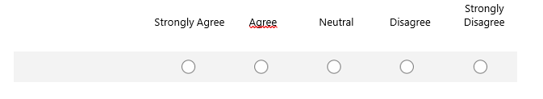


2. I feel safe at Armley Grange School

`
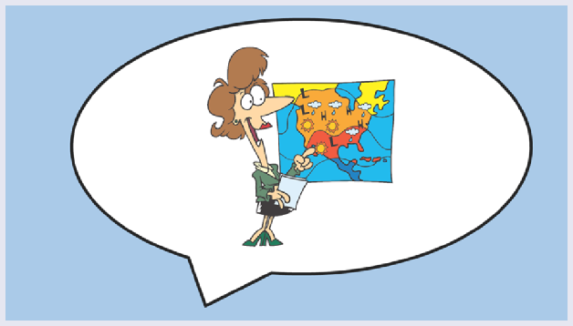
  - I think teaching is good at Armley Grange School

- I get the correct levels of support in my
lessons and I know who to ask for help if I need it

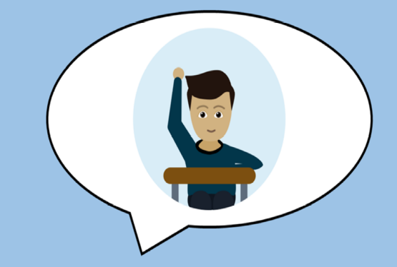

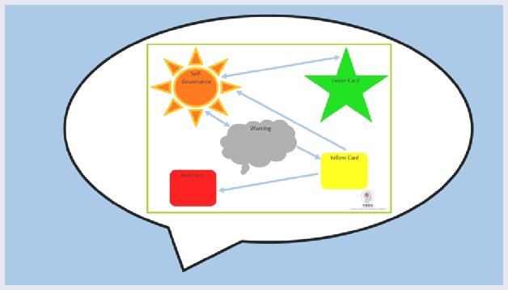

  - I know behaviour at times can be challenging
at Armley Grange School but this is always well managed


6. I feel bullying is well managed and
dealt with at Armley Grange School



7. I feel the leaders at Armley Grange School do a good
job and we feel listened to


8. Armley Grange School team members encourage me to do my best, try to work independently and support me to take responsibility for learning outcomes *

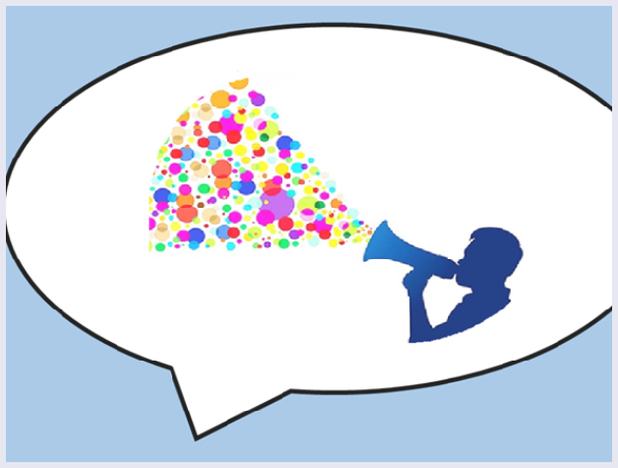
- Armley Grange School listens to my views and
actively supports student voice

- Teachers explain to me how I can achieve
more and helps me to understand and
respect people from different backgrounds

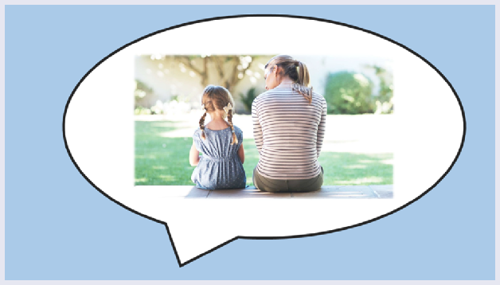
11. I feel I could speak to someone if I was
being bullied at Armley Grange School and I know
who to report this to


12. The rewards and incentive systems at
Armley Grange School encourages me to do well in
school and prompt me to reflect and take
ownership of my own behaviour


13. Please name 3 things that you
like about Armley Grange School

14. Any positive comments or suggestions you would like to share, please add below

15. Optional: You can add your name here

APPENDIX 2 – SCHOOL STUDENT SURVEY - PRIMARY

School Student Survey - Primary

Every year we ask students to complete this survey. It is a chance for you to let us know how you think we are doing.

Please answer the questions by clicking on or ticking one of the options letting us know if you agree with the statement.


I like being at Armley Grange School

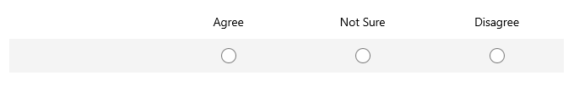



I feel safe at Armley Grange School



I think teaching here is good


I get the correct levels of support in my lessons

and I know who to ask for help if I need it



I know behaviour at times can be challenging

at Armley Grange School but this is always well managed


I feel bullying is well managed and

dealt with at Armley Grange School


I feel the leaders at Armley Grange School do a good job

and we feel listened to



Armley Grange School team members encourage me to do

my best, try to work independently and support

me to take responsibility for learning outcomes

Armley Grange School listens to my views and

actively supports student voice




Teachers explain to me how I can achieve more and helps

me to understand and respect people from different

backgrounds



I feel I could speak to someone if I was being bullied at

Armley Grange School and I know who to report this to


The rewards and incentive systems at Armley Grange

School encourage to me do well in school and

prompt me to reflect and take ownership of my

own behaviour

13. Please name 3 things that you like about Armley Grange School

- Any positive comments or suggestions you would like to share, please add below

- Optional: You can add your name here



