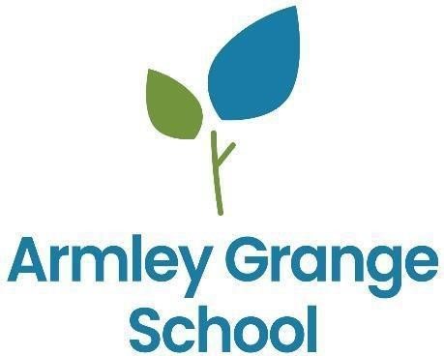

CURRICULUM POLICY

To be read in conjunction with:
- Accessibility Plan
- Equal Opportunities Policy
- E-Safety Policy
- Special Educational Needs and Inclusion
- SMSC and British Values
- Assessment
- Teaching and Learning

Date Prepared | September 2025
Date Reviewed | September 2026
Date of next review | September 2027

CONTENTS

- Legislation
- Introduction
- Curriculum pathways overview
- Nature, Develop, Thrive pathways – Intent, Implementation, Assessment and Progression routes
- Post 16 pathway
- Assessment process
- Clinical & Therapeutic Offer
- G.R.O.W.T.H. curriculum overview
- Enrichment overview
- SMSC overview

Legislation
This policy is designed to ensure that the school complies with, and exceeds, the expectations of all relevant legislation. We commit to meeting and surpassing the principles set out in The Education (Independent School Standards) (England) Regulations 2014 and Equality Act 2010 with regards to:
Curriculum:
- full-time supervised education for pupils of compulsory school age (construed in accordance with section 8 of the Education Act 1996(1)), which gives pupils experience in linguistic, mathematical, scientific, technological, human and social, physical and aesthetic and creative education;
- that pupils acquire speaking, listening, literacy and numeracy skills to the standard expected of pupils nationally;
- where the principal language of instruction is a language other than English, lessons in written and spoken English so that pupils achieve the fluency of pupils nationally in speaking, reading and writing English;
- where a student has a statement of special educational needs or an Education, Health and Care Plan, education which fulfils its requirements;
- personal, social, health and economic education which –
  - reflects the school’s aim and ethos
  - encourages respect for other people, paying regard to the protected characteristics set out in the Equality Act 2010;
- for pupils receiving secondary education, access to accurate, up-to-date careers guidance that:
  - is presented in an impartial manner;
  - enables them to make informed choices about a broad range of career options;
  - helps to encourage them to fulfil their potential;
- where the school has pupils below compulsory school age, a programme of activities which is appropriate to their educational needs in relation to personal, social, emotional and physical development and communication and language skills;
- where the school has pupils above compulsory school age, a programme of activities which is appropriate to their needs;
- that all pupils learn and make progress at the rate expected of pupils nationally;
- effective preparation of pupils for the opportunities, responsibilities and experiences of life in British society
Teaching:
- enables pupils to acquire new knowledge and make good progress according to their ability so that they increase their understanding and develop their skills in the subjects taught;
- fosters in pupils' self-motivation, the application of intellectual, physical and creative effort, interest in their work and the ability to think and learn for themselves;
- involves well planned lessons and effective teaching methods, activities and management of class time;
- shows a good understanding of the aptitudes, needs and prior attainments of the pupils, and ensures that these are considered in the planning of lessons;
- demonstrates good knowledge and understanding of the subject matter being taught;
- utilises effectively classroom resources of a good quality, quantity and range;
- demonstrates that a framework is in place to assess pupils’ work regularly and thoroughly and that pupils make good progress because teaching is planned using information from those assessments;
- utilises effective strategies for managing behaviour and encouraging pupils to act responsibly;
- does not undermine the fundamental British values of democracy, the rule of law, individual liberty and mutual respect and tolerance of those with different faiths and beliefs; (j) does not discriminate against pupil's contrary to Part 6 of the Equality Act 2010.

We also commit to meeting and exceeding the expectations set, with regards to the Spiritual, Moral, Social and Cultural development of our pupils. We will actively promote the fundamental British values of democracy, the rule of law, individual liberty and mutual respect and tolerance of those with different faiths and beliefs and will ensure that principles are promoted which:
  - enable pupils to develop their self-knowledge, self-esteem and self-confidence;
  - enable pupils to distinguish right from wrong and to respect the civil and criminal law of England;
  - encourage pupils to accept responsibility for their behaviour, show initiative and understand how they can contribute positively to the lives of those living and working in the locality in which the school is situated and to society more widely;
  - enable pupils to acquire a broad general knowledge of and respect for public institutions and services in England;
  - lead to further tolerance and harmony between different cultural traditions by enabling pupils to acquire an appreciation of and respect for their own and other cultures
  - encourage respect for other people, paying regard to the protected characteristics set out in the Equality Act 2010;
  - encourage respect for democracy and support for participation in the democratic processes, including respect for the basis on which the law is made and applied in England.

We will preclude the promotion of partisan political views in the teaching of any subject in the school and take such steps as are reasonably practicable to ensure that where political issues are brought to the attention of pupils are offered a balanced presentation of opposing views — • while they are in attendance at the school;
    - while they are taking part in extra-curricular activities which are provided or organised by or on behalf of the school;
    - in the promotion at the school, including through the distribution of promotional material, of extra-curricular activities taking place at the school or elsewhere.

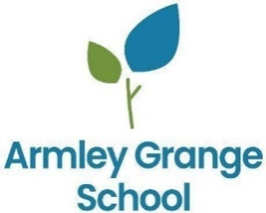
Introduction
All students at Armley Grange have complex needs with Autism being the primary need of most. Students at Armley Grange come to us with a large degree of difference in their cognitive ability so accessing learning at age-expected levels is often not something we can expect at first, however, it is always our aspiration that at some point with us, they will be able to do so.
When students arrive at Armley Grange school, they are not always available to consistently engage in education or their learning. They have often experienced a level of trauma in previous provisions, or have spent long periods, sometimes years out of education and therefore have incredibly low self-esteem. Considering Maslow’s hierarchy of need, students arrive seeking safety and security and experience high levels of anxiety within learning environments.
Our curriculum supports students' special educational needs by prioritising:
- A safe, nurturing environment, measured by student wellbeing surveys and behaviour data.
- Social development, tracked through peer interaction assessments.
- Self-esteem and self-management, evidenced by increased student independence in school tasks.
- Achievement in both academic and personal goals, monitored through formal assessments and progress reports.
Vision statement
Our curriculum underpins our vision:
"Empowering every unique mind to shine, learn, and thrive in a nurturing environment that celebrates diversity, encourages creativity, and fosters independence for a brighter future."

Curriculum aims
And in doing so we realise that it is important that our students aspire to these two key goals:
- To be themselves, aspire and be successful.
- To develop strategies and coping mechanisms to move towards a level of self-actualisation to thrive in the neurotypical world.
Our curriculum is composed of the following key components:
- Academic studies
- Social development
- Therapeutic input

By ensuring that our school’s ethos of GROWTH values is embedded in every facet of school life, inside and outside of the classroom, we have ensured that the whole child and the rounded person are just as high a priority at Armley Grange School as the progress data we produce.

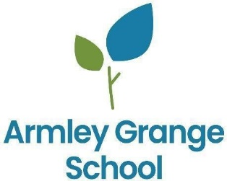

Our Curriculum
At Armley Grange School, every learner has an Education, Health and Care Plan (EHCP) and accesses a personalised curriculum and support package that is responsive to their stage of development. Students follow one of three pathways—Nature (Informal), Develop (Semi-Formal) or Thrive (Formal). Movement between pathways is possible where this best meets a student’s needs and profile. Irrespective of pathway, all students benefit from high staffing ratios, small group sizes, integrated therapeutic provision, and a strong focus on communication, self-regulation, independence and preparation for adulthood.

Curriculum Pathways
To ensure each young person is placed on the pathway that best meets their needs, we carry out an informal assessment as part of the referral process. This includes visiting the young person, gathering information from previous settings about their current curriculum and progress, and reviewing their EHCP. We also work closely with parents and carers to gain a holistic understanding of the learner’s strengths, needs and aspirations.
Assessment information from educational psychologists, alongside teacher led assessments, is used to determine the most appropriate curriculum pathway. For some learners, a personalised framework may be used to tailor specific learning intentions. This approach supports the development of metacognition and enables learners to access the national curriculum in a way that reflects their individual profile, rather than replacing it
NATURE  Informal Pathway |  | DEVELOP  Semi-Formal Pathway |  | THRIVE  Formal Pathway | 
The Nature Pathway supports learners with complex learning needs who require a highly personalised, life-skills focused curriculum. Provision prioritises communication, sensory regulation, independence and therapeutic input, guided by the EQUALS Informal Curriculum. Learning is multisensory, experiential and practical, often taking place outdoors and within real-life contexts. Assessment is primarily observation based, with progress tracked against EQUALS strands and EHCP linked Personal Learning Goals, using the school’s progression scale. |  | The Develop Pathway provides an increasingly structured curriculum while maintaining high levels of personalisation, therapeutic provision and opportunities for vocational learning. Students access a blend of academic, creative and physical subjects, alongside the wider GROWTH curriculum. Long Term Plans are adapted to learner profiles, and routines, visuals and movement breaks support engagement and regulation. Progress is tracked against subject specific outcomes, STAR assessments in Maths and Reading, and evidence captured within EFL based on EHCP linked PLGs. |  | The Thrive Pathway offers a full academic curriculum, delivered by subject specialists, for learners ready to engage with the academic demands of GCSEs and Functional Skills. Students access English, Maths, Science, Humanities, Computing, PE, PSHE, Careers and Life Skills, alongside vocational opportunities and therapeutic input where needed. Learning builds on the Develop pathway with greater emphasis on exam linked skills, subject specific assessment objectives and learning in specialist spaces. Progress is measured through baseline assessments, progression against LTP outcomes, STAR assessments and evidence captured within EFL and PLGs.

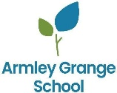
NATURE - Pre-Formal Pathway

Learner Profile
Students accessing this pathway have complex learning needs, often with a co-morbidity diagnosis. The focus is on life skills, therapeutic provision and nature-based learning guided by the EQUALS Informal Curriculum. Provision prioritises communication, sensory regulation and developing independence for learners with the most complex needs.
Intent | Implementation
- Our aim is to meet the diverse needs of our learners by focusing on communication, independence, and well-being.  - Provide meaningful, functional learning opportunities rooted in real-life contexts, helping students develop essential life skills rather than academic outcomes alone.  - Underpinned by our school’s GROWTH principles:  - Growth – Supporting individual progress in communication, social skills, and independence.  - Respect – Fostering self-respect and understanding of others in a diverse community.  - Opportunity – Creating rich, real-world experiences that promote engagement.  - Well-Being – Prioritising sensory, emotional, and physical health.  - Tolerance – Celebrating differences through inclusive and cultural learning.  - Happy – Ensuring a safe, joyful environment where pupils feel valued and motivated. | - Learning is multi-sensory, practical and experiential, often outdoors and in community contexts.  - Communication approaches include modelling, objects/sounds of reference, visuals and AAC as appropriate.  - Therapeutic sessions (e.g., Sensory Circuits, Lego Therapy, Gardening) are planned and delivered by teaching staff with input from the clinical team to support regulation and engagement. |  | - Students’ timetables are personalised to their learning and sensory needs and are highly adaptable.  - Lessons are defined using the following areas taken from the EQUALS framework  - My communication  - My sensory play  - My independence  - My music, drama and dance  - My art  - My outdoor education  - My English  - My Maths  - Learning is framed within a specific theme for each half term e.g. ‘All about me’.
Assessment |  | Progression
Assessment is observation-based and practical, focusing on real-world activities and responses to sensory, social and therapeutic interventions. Staff capture evidence through photographic records, learning journals and team discussions against EHCP outcomes and EQUALS targets that form students’ Personalised Learning Goals. This evidenced is captured on the EFL platform.  Progress is tracked termly against each of the strands within the EQUALs framework using the school’s progression scale (Emerging, Developing, Secured, Mastered). |  | Students’ progression through this pathway is analysed as part of the Annual Review process. Where appropriate, students can progress onto the semi-formal pathway.  At post 16/18, key stakeholders work with the family to secure a viable progression route either into further study within specialist provisions and/or appropriate employment.

DEVELOP - Semi-Formal Pathway

Learner Profile
Students engage with increasingly structured learning while retaining high levels of personalisation, vocational opportunities and clinical input. The curriculum is divided into discrete academic and creative/physical subjects alongside our GROWTH curriculum that encapsulates our school principles and therapeutic offer. This curriculum also allows students to pursue and develop their special interests, linking to future progression and careers.
Intent | Implementation |  | Curriculum Structure
- Provide access to a broad, relevant and motivating curriculum derived from the National Curriculum and adapted to the students’ learning profile and EHCP.  - Develop literacy, numeracy and communication alongside social, emotional and independence skills.  - Offer bespoke and personalised learning opportunities linked to students’ unique interests and skills. | - Long Term Plans produced for discrete subjects, which are adapted to meet students’ needs whilst considering their prior attainment.  - Classroom routines, visuals and regulated movement breaks support engagement and self-regulation.  - Therapeutic provision and vocational learning are integrated into weekly timetables. |  | Student timetables on the DEVELOP pathway include the following subjects:  - English  - Maths  - Science  - TOPIC (Humanities and RE)  - PSHE  - PE/Outdoor Education  - Library reading sessions  - GROWTH curriculum inc. Sensory circuits, Lego therapy, Gardening, Team building, Social Cafe
Assessment |  | Accreditation and Progression
Baseline assessments are used to determine students’ starting points within each subject’s Long Term Plan. Progress is then tracked against these baselines using range of evidence to assess students’ skills, knowledge and understanding linked to the learning outcomes within the LTP using the school’s progression scale (Emerging, Developing, Secured, Mastered).  STAR Reader and Maths assessments are also used termly an externally validated measure to track students’ progress within Maths and Reading.  The Evidence For Learning platform is also used to capture evidence linked to students’ Personal Learning Goals (PLGs) based on their EHCPs as well as curriculum areas. This is particularly pertinent for creative and practical based learning. |  | Students’ progression through this pathway is analysed as part of the Annual Review process. Where appropriate, students can progress onto the formal pathway.  Students at KS4/5 will work towards securing Entry Level and Functional Skills qualifications within English and Maths.  At post 16/18, key stakeholders work with the family to secure a viable progression route either into further study within specialist provisions and/or appropriate employment.

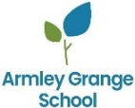
THRIVE - Formal Pathway

Learner Profile
Students access subject-specific teaching across a full academic timetable (including English, Maths, Science, Computing, Humanities, PSHE, Careers, Life Skills and PE) delivered by specialist teachers. Students on this pathway have secured a strong foundation within their core subjects to be able to engage and progress through the academic demands of the GCSE curriculum. Students still benefit from therapeutic input in addition to their timetabled curriculum where appropriate.
Intent | Implementation |  | Curriculum Structure
- Provide a broad and balanced curriculum that includes a rich blend of academic and vocational subjects.  - Prepare students for life beyond school, focusing on the skills and experiences necessary for adulthood. This includes work-related learning, community participation, and developing independence in daily life activities.  - To promote academic achievement that include formal qualifications and vocational courses. | - Long Term Plans build upon from the Develop pathway and are informed by GCSE/Func Skills specifications  - Lessons place greater emphasis on skills linked to specific assessment objectives within these specifications  - Lessons taught in specialist spaces (i.e. Science lab, Creative Arts room, Food Tech room).  - Therapeutic and vocational learning that form part of our GROWTH curriculum are incorporated into specific Careers and Life Skills lessons.  - Learning opportunities beyond the classroom are incorporated in the curriculum. E.g. Leeds College of Building sessions, off-site gym sessions, Careers visits etc. |  | Student timetables on the THRIVE pathway include the following subjects:  - English  - Maths  - Science  - Humanities  - Computing  - PE/Outdoor Education  - PSHE (inc. RE)  - Careers  - Life Skills  - Library reading sessions  Bespoke sessions at off-site provisions – Leeds College of Building also incorporated.
Assessment |  | Accreditation and Progression
Baseline assessments are used to determine students’ starting points within each subject’s Long Term Plan. Progress is then tracked against these baselines using range of evidence to assess students’ skills, knowledge and understanding linked to the learning outcomes within the LTP using the school’s progression scale (Emerging, Developing, Secured, Mastered). These align with exam specifications where relevant.  STAR Reader and Maths assessments are also used termly an externally validated measure to track students’ progress within Maths and Reading.  The Evidence For Learning platform is also used to capture evidence linked to students’ Personal Learning Goals (PLGs) based on their EHCPs as well as curriculum areas. This is particularly pertinent for creative and practical based learning. |  | Students at KS4/5 will work towards securing GCSE and/or Functional Skills qualifications within English and Maths dependent on which examination process is more suitable for each student.  Where appropriate, students will also work towards external qualifications including GCSEs in other academic subjects linked to students’ intended post-16 destinations.  Vocational qualifications also awarded e.g. BTEC Level in Construction skills via LCOB, JAS Award within Outdoor Ed etc.  At post 16/18, key stakeholders work with the family to secure a viable progression route either into further study within specialist provisions and/or appropriate employment.

POST-16 Pathway

Learner Profile
Students can continue on each of our three pathways at post-16 where this has been determined as the most viable and suitable option following their end of KS4 placement review. Students will continue to study in each subject area based on their prior attainment and progress with greater emphasis placed on developing independence and life skills. Students’ curricula can also be tailored to their intended future career path and progression route.
Intent | Implementation |  | Curriculum Structure
- Provide a bespoke and tailored curriculum specific to each student and their future aspirations and progression routes.  - Prepare students for life beyond school, focusing on the skills and experiences necessary for adulthood. This includes work-related learning, community participation, and developing independence in daily life activities.  - Promote aspirational career paths linked to the students’ interests and skills and provide tangible experiences of the workplace as part of their curriculum. | - Long Term Plans provide a continuation of learning from previous pathways.  - Lessons place greater emphasis on skills linked to specific assessment objectives within these specifications  - Lessons taught in specialist spaces (i.e. Science lab, Creative Arts room, Food Tech room).  - Therapeutic and vocational learning that form part of our GROWTH curriculum are incorporated into specific Careers and Life Skills lessons.  - Learning opportunities beyond the classroom are incorporated in the curriculum. E.g. Leeds College of Building sessions, off-site gym sessions, Careers visits etc. |  | Student timetables mirror that of their KS4 pathway but can be adapted to include bespoke sessions linked to their intended career paths
Assessment |  | Accreditation and Progression
Baseline assessments are used to determine students’ starting points within each subject’s Long-Term Plan. Progress is then tracked against these baselines using range of evidence to assess students’ skills, knowledge and understanding linked to the learning outcomes within the LTP using the school’s progression scale (Emerging, Developing, Secured, Mastered). These align with exam specifications where relevant.  STAR Reader and Maths assessments are also used termly an externally validated measure to track students’ progress within Maths and Reading.  The Evidence for Learning platform is also used to capture evidence linked to students’ Personal Learning Goals (PLGs) based on their EHCPs as well as curriculum areas. This is particularly pertinent for creative and practical based learning. |  | Students at KS5 will work towards securing qualifications within English and Maths dependent on which examination process is more suitable for each student and their attainment at KS4.  Vocational qualifications also awarded e.g. BTEC Level 1 in Construction skills via LCOB, JAS Award within Outdoor Ed etc.  At post 18, key stakeholders work with the family to secure a viable progression route either into further study within specialist provisions and/or appropriate employment.

Assessment Process
Following an initial baseline assessment process, an initial baseline judgement is made for each student at the start of the year to act as a relative starting point. Three assessment points are taken at the end of each term to determine progress made against the learning outcomes within each subject areas’ Long-Term Plan. This judgement is informed by the school’s Progression Scale.
NATURE – pre-formal pathway | DEVELOP – Semi-formal pathway |  | THRIVE – Formal pathway
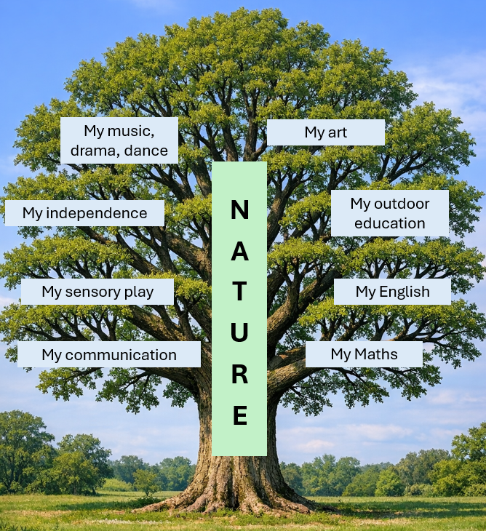 | 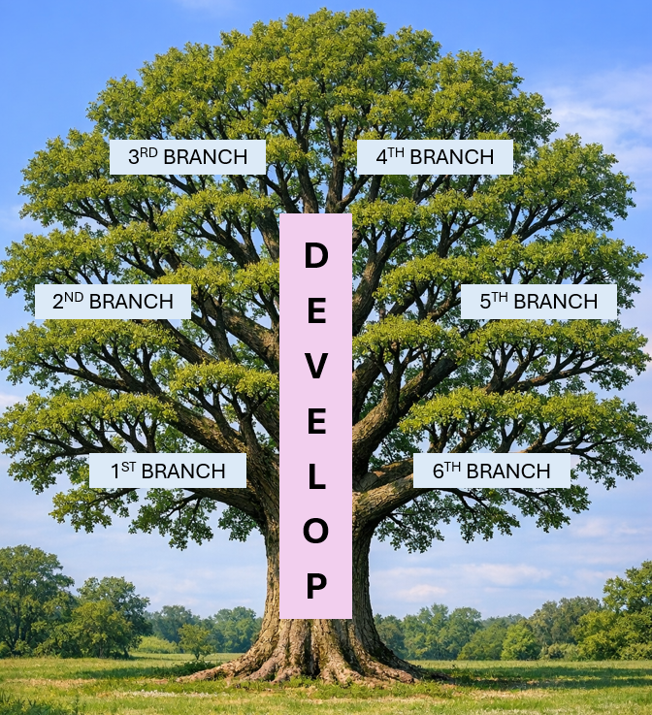 |  | 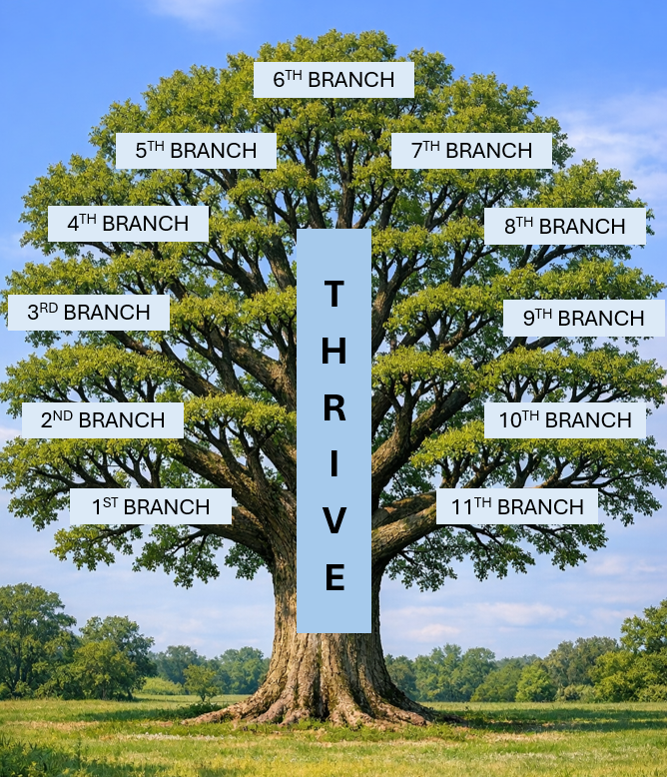
The tree above represents the key strands of the EQUALS framework that our Nature pathway is built upon. A judgement is made against each strand/branch based on our progression scale. These judgements are informed by evidence gathered within EFL and assessed against the EQUALS framework. | Branches 1-11 represent the age-related expectations in each subject from KS1 to KS4 (Years 1-11). The DEVELOP pathway progresses from Branches 1-6 to relate to KS1-2 age-related expectations, after which they will progress onto the THRIVE pathway. Teacher judgements are made within each discrete subject based on the forms of assessment outlined in each subject’s Long Term Plan using the school’s Progression Scale. STAR Reader/Maths assessments are also used to inform progress within English and Maths. Levels are referred to as branches as opposed to NC years as students may work at different levels to their chronological age.
PROGRESSION SCALE |  | PERSONAL LEARNING GOALS (Linked to EHCP outcomes)
 |  | Each student has personalised targets (PLGs) based on their specific learning needs outlined in their EHCP. These targets are set termly and incorporate the school’s progression scale. Targets are set within the following areas linked to EHCPs:  - Cognition and Learning  - Communication and Interaction  - Social, Emotional and Mental Health  - Physical and Sensory needs  - Independence and Preparing for Adulthood
  Level | Descriptor | Approximate coverage of LTP
  Emerging | Baseline level – high level of prompt/support | 10%+
  Developing | Evidence of progress, lower level of prompt/support | 40%+
  Secured | Skill/knowledge used frequently and maintained over time. Most independent with some support | 70%+
  Mastered | Skill/knowledge consistently applied and in different contexts. Completely independent, little to no support | 90%+

Clinical & Therapeutic Offer
The following summarises the different levels of our Clinical Offer as part of Outcomes First Group
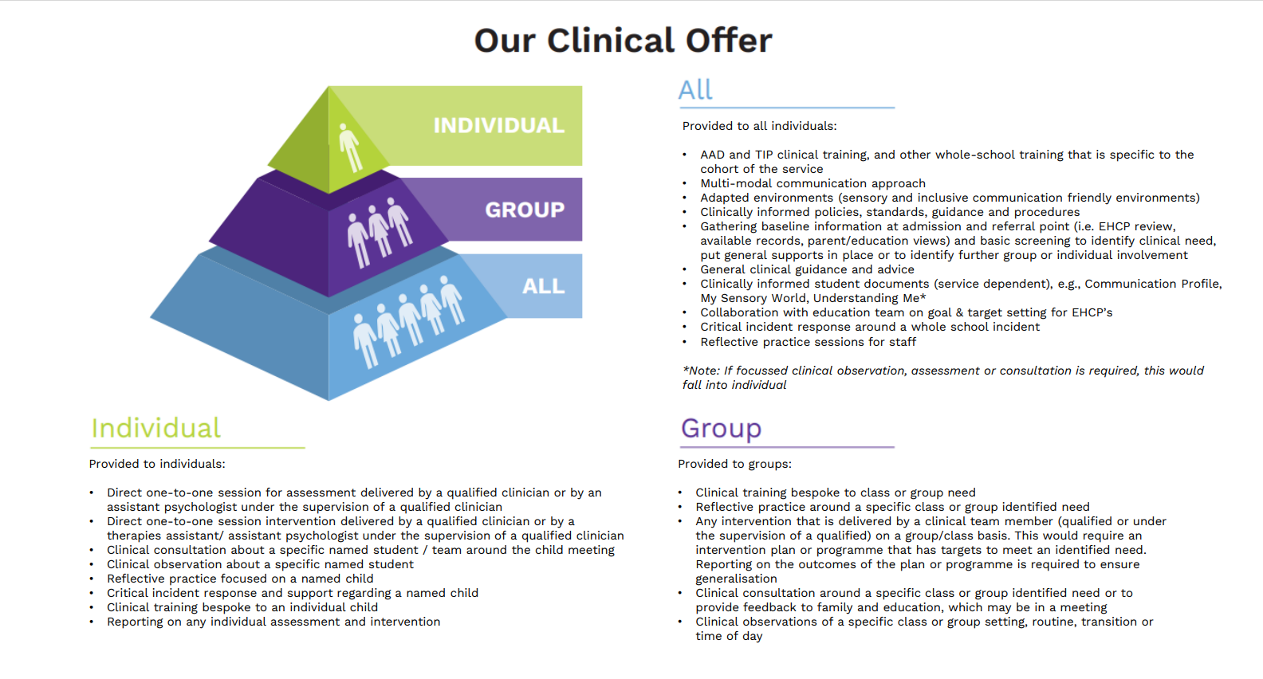

Clinical & Therapeutic Offer – Summary of Provision at Armley Grange
Stage | Action | Who | Who Does What
1. Universal Support (For All Students) | Zones of Regulation: All students can use the Zones of Regulation framework to understand and manage their emotions (e.g., using colour zones to help students identify their current emotional state). | All Staff | Teaching staff introduce and implement Zones of Regulation and support students in using it for self-regulation. TA’s reinforce these strategies throughout the school day.
1. Universal Support (For All Students) | ASK-ACCEPT-DEVELOP: This framework supports clear and consistent communication with students, particularly those who may struggle with social interactions. | All Staff | All staff to use- Teachers implement AAD in daily classroom routines, reinforcing appropriate social exchanges with students. TA’s reinforce these strategies throughout the school day.
1. Universal Support (For All Students) | Trauma-Informed Language: All staff should use trauma-informed language to ensure a safe, supportive environment, recognising that some students may have experienced trauma or have difficulty regulating emotions. | All Staff | All staff to use- Teachers implement TIP in daily classroom routines, reinforcing appropriate social exchanges with students. TA’s reinforce these strategies throughout the school day.
1. Universal Support (For All Students) | LEGO Therapy: As a universal social skills activity, LEGO Therapy can be used to support students in developing communication, social interaction, and problem-solving skills. | Teachers and TA’s.  (SaLT to Support) | All staff to use- Teachers and TA’s to implement Lego Therapy in daily classroom routines. (SaLT to support and upkeep).
1. Universal Support (For All Students) | Sensory Circuits: Sensory circuits can be used throughout the day to support students in self-regulation by providing sensory stimulation and self-calming techniques that enhance focus and attention. | Teachers and TA’s.  (OT to Support) | All staff to use- Teachers and TA’s to implement Sensory Circuits in daily classroom timetables. (OT to support and upkeep).
2. Enhanced Support (For Students Requiring Additional Support) | Pastoral Support: All students benefit from Pastoral Support, especially those struggling with well-being or social-emotional difficulties. This support provides a safe space for students to express concerns and receive guidance. | Pastoral | Pastoral Support Staff provides emotional guidance and reassurance. They also help students with peer  relationships, conflict resolution, and general well-being.
 | ELSA: For students showing more persistent emotional needs or difficulties with self-regulation, an ELSA provides targeted support in emotion management, social skills, and building resilience. | ELSA | ELSA works with students on a one-to-one or small group basis, providing emotional support and teaching skills for emotional regulation, social interaction, and resilience.
 | EHCP: The EHCP outlines necessary provisions, ensuring collaboration between school staff, families, and external professionals. It guarantees legal entitlement to support, helping students access the appropriate educational and therapeutic services. | All staff  (SENCo to Support) | All staff- However, the SENCO ensures appropriate interventions, assessments, and accommodations are in place.
 | Mental Health First Aider (MHFA): If a student or staff member is in emotional crisis, struggling with anxiety or other significant emotional distress, a Mental Health First Aider provides immediate support and connects the student to appropriate resources. | MHFA | MHFA provides emotional support, de-escalates crisis situations, and refers to additional support if necessary.
 | Signposting: Staff may also be asked to signpost students or families to our website, additional mental health services or our clinical team. | All Staff  (DSL to Support) | All staff- DSL will follow up on safeguarding concerns, ensuring referrals to external services (e.g., CAMHS, family services) or our Clinical team. Staff should involve DSL as soon as safeguarding concerns arise.
3. Specialist Support (For Clinical or Therapeutic Intervention) | Referral to Clinical Team: If a student requires therapeutic intervention for deeper emotional, psychological, or sensory needs (e.g., psychotherapy, OT, SALT), a referral to the clinical team should be made. This can be an escalating step if prior interventions haven’t fully addressed the student’s needs. | Clinical Team | Clinical Lead coordinates the referral process to internal or external services, providing psychological therapy, OT or speech and language support as needed.

G.R.O.W.T.H. Curriculum

We seek to embed our values into all aspects of our school. We refer to these as our GROWTH principles, which are:
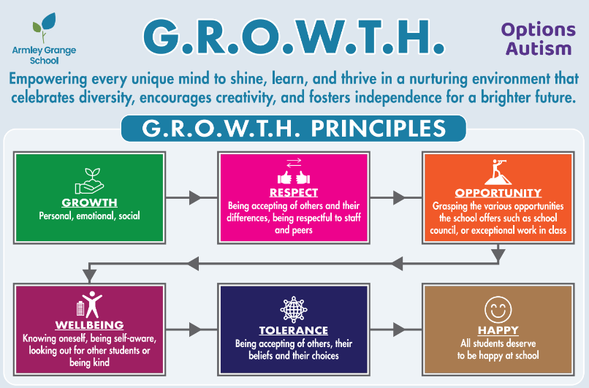

Growth – Personal, emotional, social

Respect – Being accepting of others and their differences, being respectful to staff and peers

Opportunity – Grasping the various opportunities the school offers

Wellbeing – Knowing oneself, being self-aware, looking out for other students or being kind

Tolerance – Being accepting of others, their beliefs and their choices

Happy – All students deserve to be happy at school

We also seek to explicitly link these principles within our curriculum and as such, have built time into the timetable within each pathway for students to engage in GROWTH curriculum lessons. These lessons serve to achieve 3 main aims:

Dedicated time for therapeutic input linked to our clinical offer to boost students’ wellbeing and happiness. This includes specific sessions – Zones of Regulation, Sensory Circuits, Lego Therapy and Gardening.
- Develop students’ social communication and interaction skills by promoting respect and tolerance. This includes specific sessions – Team building, Social Café, Outdoor Education and is also incorporated into PSHE and Life Skills.
- Embrace and value students’ special interests by providing them with the opportunity to grow and develop specific skills related to these interests. This includes providing students with bespoke opportunities linked to their interests. For example, bike maintenances sessions, music production, bespoke trips etc. This also is incorporated into our Careers Programme, in which we provide students with tangible experiences of careers and workplaces linked to their special interests.

Enrichment
We recognise the power that an enriched experience within a child’s education has on their development. We seek to broaden our students’ horizons through a range of different experiences and opportunities that will raise their aspirations and cultural capital. We have a regular enrichment timetable within school for students to engage in at social times ranging from music and drama clubs to board games, arts & crafts and debating. We also plan in regular off-site trips that are used for both educational purposes and as rewards for students’ engagement and effort. These include regular trips to colleges, art exhibitions, climbing centres, cinemas, even trips to the seaside.

Social, Moral, Spiritual and Cultural education, and British values
We recognise that social, moral, spiritual and cultural education (SMSC) including British values plays a significant part in the personal development of our learners. SMSC is a dimension of the whole school experience which makes the curriculum relevant, creative, stimulating and fun. It enriches the curriculum and ethos of our school.
At Armley Grange school we hold a collective assembly each Friday morning where we can help our students to understand various topics that will inevitably affect them throughout their lives. This allows us to cover aspects for the RE curriculum in an informal way as well as dovetailing with areas of school that are pertinent to that week, such as World Book Day, National Recycling Week or International Literacy Day. Alongside these one-off events, we have a rota of assemblies which reflect our GROWTH principles. A senior member of staff will be allocated a principle at the start of the year and will present at an assembly over a 7-week cycle, with our 7th week always being based around a safeguarding topic, such as staying safe online. Our SMSC events during this academic year are shown below:
SMSC Calendar 2026/27

International Literacy Day 08/09/26
National Computing Week 14/09/26
European Day of Languages 25/09/26
Black History Month 01/10/26
National Poetry Day 02/10/26
Space Week 05/10/26
National Libraries Week 12/10/26
Diwali (Hinduism & Islamism) 19/10/26
World Culture Day 23/10/26
Anti Bullying Week 09/11/26
Remembrance Day 11/11/26
Geography Awareness Week 16/11/26
Computer Science Week 07/12/26
Christmas Assembly (Christianity)
Christmas Fair – Parent inclusion
Chinese New Year 08/02/27
Safer Internet Day 09/02/27
World Culture Day 12/02/27
Children's Mental Health Week 22/02/27
Safer Internet Day 10/02/26
World Book Day 04/03/27
British Science Week 08/03/27
National Careers Week 15/03/27
Shakespeare Week 19/03/27
Earth Day 22/04/27
International Museums Day 18/05/27
World Culture Day 28/05/27
Pride Month 07/06/27
World Oceans Day 08/06/27
Healthy Eating Week 14/06/27
World Music Day 21/06/27
World Rainforest Day 22/06/27

