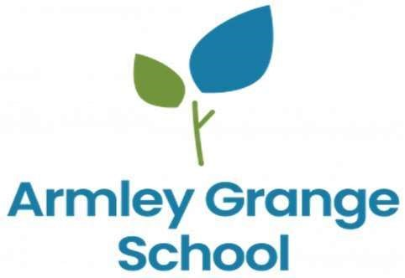
School Term and Holiday Dates
Autumn Term 2026
Term Starts | Tuesday 1st September (Inset Days Tue 1st & Wed 2nd)
Mid Term Closure | Monday 26th October – Friday 30th October
End of Term | Friday 18th December – Christmas Fair (12pm Finish)

Parental Consultation Evening – Wednesday 16th December
Spring Term 2027
Term Starts | Tuesday 5th January 2027 (Inset Days Mon 4th January)
Mid Term Closure | Monday 15th February - Friday 19th February 2027
Easter Bank Holiday | Friday 26th March – Monday 29th March 2027
End of Term | Friday 2nd April – Easter Celebration (12pm Finish)

Parental Consultation Evening – Wednesday 31st March
Summer Term 2027
Term Starts | Monday 19th April 2027
Bank Holiday | Monday 3rd May (school will be closed)
Mid Term Closure | Monday 31st May – Friday 4th June 2027
End of Term | Thursday 22nd July – End of Year Parent Event (12pm Finish)

Parental Consultation Evening – Wednesday 14th July
INSET days are as follows – school closed to students:
Day 1: Tue 1st Sept 2026
Day 2: Wed 2nd Sept 2026
Day 3: Mon 4th Jan 2027
Day 4: Friday 16th April – During Easter Holidays – Does not affect students

