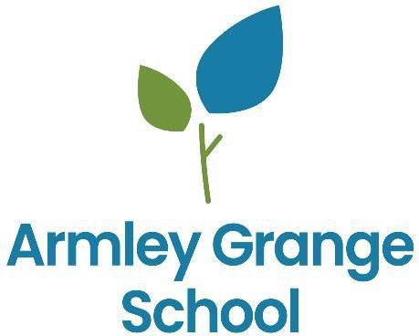

CURRICULUM POLICY

To be read in conjunction with:
- Accessibility Plan
- Equal Opportunities Policy
- E-Safety Policy
- Special Educational Needs and Inclusion
- SMSC and British Values
- Assessment
- Teaching and Learning

Date Prepared | September 2022
Date Reviewed | September 2023
Date of next review | September 2024

CONTENTS

Legislation Curriculum Intent
  - Curriculum Rationale
  - Curriculum Aims
  - Curriculum Design

Curriculum Implementation

  - Curriculum Structure

Curriculum Impact

  - Pathway Assessment
  - Post 16 provision
  - Additional Information

Legislation
This policy is designed to ensure that the school complies with, and exceeds, the expectations of all relevant legislation. We commit to meeting and surpassing the principles set out in The Education (Independent School Standards) (England) Regulations 2014 and Equality Act 2010 with regards to:
Curriculum:
- full-time supervised education for pupils of compulsory school age (construed in accordance with section 8 of the Education Act 1996(1)), which gives pupils experience in linguistic, mathematical, scientific, technological, human and social, physical and aesthetic and creative education;
- that pupils acquire speaking, listening, literacy and numeracy skills to the standard expected of pupils nationally;
- where the principal language of instruction is a language other than English, lessons in written and spoken English so that pupils achieve the fluency of pupils nationally in speaking, reading and writing English;
- where a student has a statement of special educational needs or an Education, Health and Care Plan, education which fulfils its requirements;
- personal, social, health and economic education which –
  - reflects the school’s aim and ethos
  - encourages respect for other people, paying particular regard to the protected characteristics set out in the Equality Act 2010;
- for pupils receiving secondary education, access to accurate, up-to-date careers guidance that:
- is presented in an impartial manner;
- enables them to make informed choices about a broad range of career options;
- helps to encourage them to fulfil their potential;
- where the school has pupils below compulsory school age, a programme of activities which is appropriate to their educational needs in relation to personal, social, emotional and physical development and communication and language skills;
- where the school has pupils above compulsory school age, a programme of activities which is appropriate to their needs;
- that all pupils learn and make progress at the rate expected of pupils nationally;
- effective preparation of pupils for the opportunities, responsibilities and experiences of life in British society
Teaching:
- enables pupils to acquire new knowledge and make good progress according to their ability so that they increase their understanding and develop their skills in the subjects taught;
- fosters in pupils self-motivation, the application of intellectual, physical and creative effort, interest in their work and the ability to think and learn for themselves;
- involves well planned lessons and effective teaching methods, activities and management of class time;
- shows a good understanding of the aptitudes, needs and prior attainments of the pupils, and ensures that these are taken into account in the planning of lessons;
- demonstrates good knowledge and understanding of the subject matter being taught;
- utilises effectively classroom resources of a good quality, quantity and range;
- demonstrates that a framework is in place to assess pupils’ work regularly and thoroughly and that pupils make good progress because teaching is planned using information from those assessments;
- utilises effective strategies for managing behaviour and encouraging pupils to act responsibly;

- does not undermine the fundamental British values of democracy, the rule of law, individual liberty and mutual respect and tolerance of those with different faiths and beliefs;
- does not discriminate against pupils contrary to Part 6 of the Equality Act 2010.

We also commit to meeting and exceeding the expectations set, with regards to the Spiritual, Moral, Social and Cultural development of our pupils. We will actively promote the fundamental British values of democracy, the rule of law, individual liberty and mutual respect and tolerance of those with different faiths and beliefs and will ensure that principles are promoted which:
- enable pupils to develop their self-knowledge, self-esteem and self-confidence;
- enable pupils to distinguish right from wrong and to respect the civil and criminal law of England;
- encourage pupils to accept responsibility for their behaviour, show initiative and understand how they can contribute positively to the lives of those living and working in the locality in which the school is situated and to society more widely;
- enable pupils to acquire a broad general knowledge of and respect for public institutions and services in England;
- lead to further tolerance and harmony between different cultural traditions by enabling pupils to acquire an appreciation of and respect for their own and other cultures
- encourage respect for other people, paying particular regard to the protected characteristics set out in the Equality Act 2010;
- encourage respect for democracy and support for participation in the democratic processes, including respect for the basis on which the law is made and applied in England.

We will preclude the promotion of partisan political views in the teaching of any subject in the school and take such steps as are reasonably practicable to ensure that where political issues are brought to the attention of pupils are offered a balanced presentation of opposing views —
  - while they are in attendance at the school;
  - while they are taking part in extra-curricular activities which are provided or organised by or on behalf of the school;
  - in the promotion at the school, including through the distribution of promotional material, of extra-curricular activities taking place at the school or elsewhere.

Intent

Curriculum Rationale
Armley Grange School is a day school for boys and girls aged 5 to 19; all of our pupils have significant barriers to learning due to their complex learning difficulties and disabilities in the area of autism spectrum disorder, learning difficulties, associated social, emotional and mental health conditions and medical and health issues. Pupils are placed from a wide range of local authorities and they all have an Education, Health and Care Plan (EHCP). All of our pupils have experienced significant barriers to learning, due to either their developmental profile, negative life experiences, or both. Before joining our school many have been unable to access a school-based curriculum effectively, and many have experienced multiple placement breakdowns. As a result, pupils start their time at Armley Grange with significant gaps in their learning and many are working below age-related expectations.

At Armley Grange the curriculum covers every planned learning experience the pupils have as a member of the school. It consists of all planned activities that we organise in order to promote learning, personal growth, and development. Teachers, support staff, therapists and instructors structure these experiences to ensure that they have the most positive effect on the attainment, progress and personal development of all pupils. Our curriculum also incorporates the opportunistic learning experiences that occur throughout the day, and which staff pro-actively seek out and capitalise on in line with the autism- specific elements of our curriculum framework.

Curriculum Aims
Regardless of the age at which our pupils join us, our priority from the outset is to ensure they are ready for the next stage of their journey. Our curriculum is designed to prepare our pupils for life in modern Britain, and to address any barriers to learning they experience as a result of their autism, additional diagnoses, or past experiences. We understand that at Armley Grange the learning journey, personal circumstances and educational and personal outcomes for every pupil are entirely unique, and so our curriculum strives to provide pathways to vocational and academic qualifications that match the capacity and potential of each learner. Our curriculum is broad, challenging and varied, and provides pupils with rich learning experiences that are both highly personalised, and aligned to the structures that lead to formal, external accreditation. We are committed to core British Values, including democracy, the rule of law, individual liberty, mutual respect for, and tolerance of, those with different faiths and beliefs, and through our PSHE curriculum we actively promote our pupils’ understanding of and respect for a diverse range of people, especially those who belong to groups susceptible to discrimination. As a school for children with autism, our aim is that pupils make the maximum progress possible in the areas of difficulty typically associated with that diagnosis, including their social communication, emotional regulation, and sensory processing. Our curriculum also aims to ensure pupils are able to both sustain and generalise the skills they acquire, over time, and across different contexts and circumstances. Above all, our aim as a school is to ensure our pupils leave us with the highest possible levels of independence and autonomy, whether that be through the acquisition of practical and academic skills, regulation of their own sensory and emotional needs, or effective articulation of their own choices and pursuit of their own interests and life goals.

Given the diversity of needs and strengths across our pupil population, we aim to establish and sustain the very highest standards of teaching and learning in order that gaps and specific areas of challenge can be addressed and overcome. There are three key factors within our control that will enable us to do this. These are:
    - The Environment. The physical environment (and the resources within it) must be carefully designed and managed to actively contribute to pupils’ learning. We aim to provide a therapeutic, supportive and nurturing environment for each individual.
    - Our Expectations. The level, type and volume of work in any activity or lesson must be specifically tuned to the needs and abilities of individual learners. Expectations placed on pupils must build on their previous experiences, and promote the highest possible level of progress.
    - Pupil Experience. Engagement is key to successful learning. In line with the research behind The Leuven Scales, SCERTS, PBS and Attention Autism, our curriculum, therefore, is predicated on the wellbeing and involvement of all pupils.

Curriculum Design

Our pupils require us to have an agile and reflexive approach to curriculum design. The need for our curriculum to be flexible, adaptable and robust enough to meet the ever-changing demands of the modern world, and best prepare our pupils for a life within it, is the cornerstone of this policy, and our curriculum will also be shaped by and adapted to the needs of our diverse and changing pupil population.
The curriculum and teaching and learning approaches used are designed to reduce barriers to learning and ensure good progress and positive engagement. It is the expectation that all pupils will access a curriculum which supports them to fulfil their potential.
Approaches used to plan and deliver the curriculum are devised to meet the needs of individual learners, for some this will be through specialist subject focused approaches. For others it is more appropriate to base approaches on a suitable Personalised Framework.
The learning experiences are carefully planned and structured to ensure continuity and cohesion and that each pupil is enabled to make the very best progress in the development of their knowledge and skills.

Our planning is driven by the pupil’s needs and interests, whilst also being informed by Development Matters, National Curriculum, 14 – 19 Curriculum, PSHE Association Planning Framework for Pupils with SEND and the Autism Education Trust’s Pupil Progression Framework.
The Senior Leadership Team are responsible for monitoring the planning and delivery of the curriculum utilising a quality assurance framework. This monitoring is organised into an annual timetable of deep dives, alongside short reviews and audits, training and development as well as outlining any changes to the curriculum and the planning and provision of resources. This is carried out alongside Subject leads, in order for them to action plan their subject in order to improve provision.

In order to ensure the pupils are accessing the curriculum that is appropriate to their needs, we assess them informally around the time of referral by making visits to the pupil, speaking with previous placements regarding current curriculum and progress, and reviewing the current EHCP. Alongside this,

we would discuss their needs with parents and carers to gauge an overview of how they would be best placed within school.

On admission to the school, some pupils have experienced multiple failures and exclusions from previous settings. As well as this, these children will have most likely have significant gaps in learning and metacognition, due to a multitude of barriers to learning. The curriculum implementation utilises a spiral curriculum approach, scaffolding and building upon skills and knowledge with the aim of progressively increasing competency, taking into consideration the learner’s cognitive load.
The curriculum acknowledges the differing strengths and needs of individuals and recognises the fact that some may need to spend far more time than others in a given area of learning and that for some individual’s certain skills may remain always inaccessible and therefore need to be bypassed or replaced. The curriculum pace is flexible and aims to close learning gaps that are meaningful. Some learners may utilise the personalised framework to develop their metacognition to support them in best access the National Curriculum, as opposed to replacing it.

Underpinning all of this is our obligation to meet the specific individual needs outlined in each pupil’s Education Health and Care Plan; these objectives are central to the evidence of learning we capture on a daily basis.

Our curriculum is designed on the following 10 principles:
- Meeting individual needs is set in the context of a broad, balanced, relevant and differentiated curriculum that helps pupils understand the world in which they live.
- The most significant barriers to learning for some pupils stem from negative (or restricted) social and educational experiences in the past. Establishing and sustaining engagement in learning is key.
- The three priorities in our curriculum design are functional literacy, functional numeracy, and
personal development (incorporating our ASD curriculum).
- The wellbeing of all learners is fundamental to their success in school and beyond.
- Outstanding progress is possible for every pupil at Armley Grange but will look different for every pupil. The curriculum should be sufficiently flexible to enable pupils to achieve and exceed the expectations outlined in their personalised targets and Education, Health and Care Plans.
- External examinations and accreditation may be appropriate for some pupils, and our curriculum should provide pathways to academic success where that is the case.
- Development of communication, sensory processing and emotional regulation skills are fundamental to the progress our pupils make.
- The path towards maximum independence and autonomy when leaving us at 16-19 starts on a
pupil’s first day at Armley Grange.
- All pupils are entitled to a curriculum that supports the development of their personal moral values, respect for religious values, and tolerance of other people’s backgrounds, beliefs and ways of life
- Our pupils may need to be grouped with reference to their needs and cognitive ability, rather than strictly on their chronological age

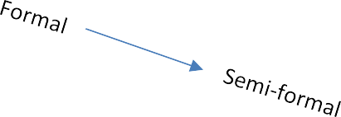
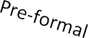
Focus on skill mastery.
Coverage of content

Implementation

B.1 Curriculum Structure

We have segmented our curriculum into Pathways to encompass all learning journey’s for our pupils. Below is a description of each of these pathways and how we teach them across the school. It is key to note that every child’s learning journey is different and as a school we have varied expectations of progress dependent on that child’s needs. Our pupils will be assessed as above when they get referred to us and using a multi-disciplinary approach, we will map out their curriculum using a pathway that best suits their needs at the time. This will be reviewed every term and the pathways are made fluid so that a pupil can move between pathways if needed.

In order to ensure the pupils are accessing the pathway that is appropriate to their needs, we assess them informally around the time of referral by making visits to the child, speaking with previous placements regarding current curriculum and progress, and reviewing the current EHCP. Alongside this, we would discuss their needs with parents and carers to gauge and overview of how they would be best placed within school. Educational psychologist assessments, and teacher led assessment will inform the curriculum pathway best suited to the child/YP.

Pathway | Learning Style | Curriculum/Assessment
Pathway 1 | Formal | National Curriculum
Pathway 2 | Semi-formal | NC/ AET Pupil Progression Framework
Pathway 3 | Pre-formal | AET Pupil Progression Framework

Pathway 1 (formal)

This pathway consists of the EYFS- Development Matters or National Curriculum (age dependent).
The first steps of target setting for the pupils who are accessing the national curriculum is to find out where they were in their previous placement, if appropriate; from this the teacher will then complete baseline assessments in order to ensure correct judgement. They will then baseline the child on Evidence for Learning in order to produce next steps and appropriate learning for them. This process usually takes a half term at least due to the pupil settling into a new environment.
During this time, the young person will be assessed by a range of specialists at the school, which will further inform how they learn, as well as identifying interventions that may need to be in place in order for them to extend their learning. These professionals include, Educational Psychologists, Occupational therapist and Speech and Language therapists.
This is a formal learning pathway, which means they are working on National Curriculum targets set to their ability.
Teachers plan from a wider curriculum map and are expected to have medium term planning for the classes they teach, which clearly outlines differentiation for the needs of the pupils. The teacher should also ensure that outcomes are clearly stated on their planning to inform others where the young person is expected to reach. Subsequently, half termly, teachers are then expected to update the National Curriculum monitoring system (Evidence for Learning) with evidence of achieved targets.

Pathway 3 (pre-formal)

Armley Grange School offers a specially adapted curriculum pathway for pupils with Autism Spectrum Disorder (ASD) and significant learning difficulties. This is a person centred, needs led approach rather than a subject based content driven approach which has been developed in order to facilitate the planning and assessment of learning for pupils who are working below the National Curriculum and who don’t make progress in a neuro-typical way. The overall design of this framework addresses some key issues relating to appropriate learning approaches for pupils with severe and profound learning difficulties.
This curriculum ensures that learning is ambitious for children; it is centred on what that person needs and wants at its very core, and means progress is achievable for all. It enables teachers to focus on those things that will have the most impact on pupil’s lives. Personalisation involves stripping away the less important areas of learning and focusing on the more important ones. This is critical to making the best of what is limited time in school, and create a road to their future that is focused on their wellbeing and independence.
Based on collaboration between the Autism Centre for Education and Research (ACER) at Birmingham University and the Autism Education Trust (AET) this pathway is designed to capture individual pupils’ learning needs as well as addressing the specific social, emotional, sensory and communication needs associated with autism; it fosters their independence and well-being and creates an inclusive learning environment.
Commissioned by the Department for Education, and based on research and consultation with a wide range of practitioners, academics, parents, and people on the autism spectrum (AET, 2021), the AET Autism Progression Framework 2.0 provides the structure for Armley Grange’s specialist pathway.

Pathway 2 (semi-formal)

This is a split between the two pathways above; it allows our pupils to access areas of the national curriculum on a highly personalised approach while also working on individual pupils’ learning needs as well as addressing the specific social, emotional, sensory and communication needs. Our pupils will have elements of the national curriculum built into their wider curriculum, or may access a minimised subject framework for one or more of the core subjects (English, Maths, Science).

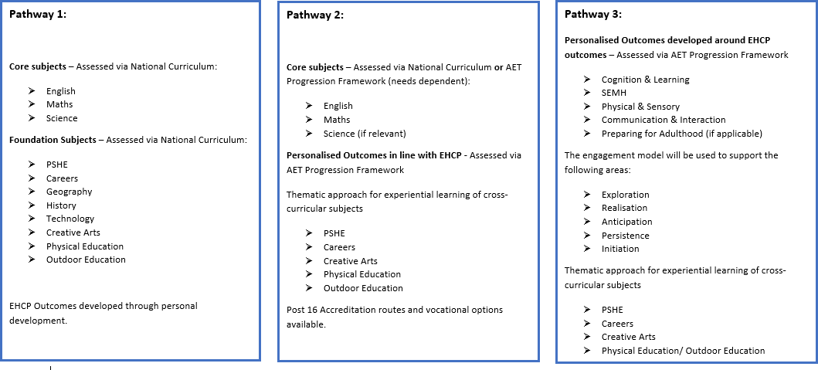

The AET Pupil Progression Framework is built on the following areas:

Communication and interaction | - Engaging in interaction  - Making requests
- Communicating information / commenting on events
- Listening and understanding
- Greetings
 | 6. Conversations
 | 7. Non-verbal communication
Social understanding and relationships | 1. Being with others
 | 2. Interactive play
 | 3. Positive relationships (supporting adults)
 | 4. Positive relationships and friendships (peers)
 | 5. Group activities
Sensory processing | - Understanding and expressing own sensory needs  - Responding to sensory interventions  - Increasing tolerance of sensory input  - Managing own sensory needs
Interests, routines and processing | - Coping with change  - Transitions
 | 3. Special interests
 | 4. Problem solving andthinking skills
Emotional understanding and self-awareness | - Understanding and expressing own emotions  - Managing emotions and behaviour  - Understanding others’ emotions/ intentions  - Self-awareness  - Developing confidence and self-esteem
Learning and engagement | - Learning through play  - Motivation and engagement  - Organisation andindependent learning  - Understanding and following rules, routines and expectations  - Evaluating own learning
Healthy living | - Keeping Healthy  - Personal Care  - Relationships and Sex Education
Independence and community participation | - Independent Living  - Personal Safety  - Road Safety and Travel  - Leisure

Impact

Pathway Assessment

Pathway 1 (formal)
This pathway is assessed formally through Evidence for Learning against National Curriculum targets or where age-appropriate, Early Years Foundation Stage; teachers are expected to evidence the targets met for all subjects taught to that pupil. They should make ongoing judgements, which then articulates next steps and further development points. Targets that have been met and evidenced are then peer moderated to ensure the correct judgements have been made; this is done on a termly basis.

Progress is categorised as Slow, Steady or Exceptional; where progress is steady or exceptional no further work is required. However, where progress is slow, a second moderation takes place whereby a subject lead and a member of SLT will support and action where applicable.
The pupils that follow this pathway could be working towards formal certification and accreditation; this could be in the form of SATs/ GCSE’s/ Open Awards or Functional Skills.

Pathway 3 (pre-formal)
The Progression Framework provides an extensive ‘bank’ of learning intentions based on an understanding of autism and the challenges that pupil may face within education settings. It is by no means exhaustive and we tailor learning intentions according to each individual’s needs.

This is assessed using the progression framework where a pupil’s learning intentions are activated and baselined at the beginning of their journey using the progress scale (see below). It is recommended that 5-6 intentions are worked on over a period of time, i.e. a term however this will differ for individuals.
Learning intentions are reviewed termly however, if we believe a pupil is generalising an intention before this review period, a discussion with all relevant professionals to identify an appropriate intention to further challenge and progress the child will be had.
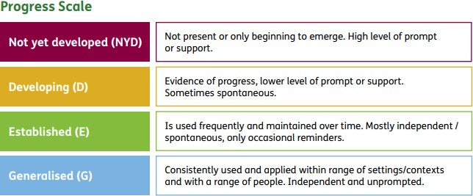

Pathway 2 (semi-formal)
This pathway is assessed against the above two processes. Where the pupils are using National Curriculum targets, these frameworks are amended to ensure they are achievable and fit the needs of our pupils on an individual basis.
Some of our pupils on this pathway may work towards elements of an accreditation in on or more specific subjects, but this decision will be on an individualised basis.

Post 16 Provision
Post 16 pupils continue to be involved in planned learning consisting of core and foundation subjects including Independent Life skills, PSHE, Careers, Enterprise and vocational options. As within the primary and secondary provision, some pupils follow a more personalised approach.
The Post 16 timetable aims to support pupils growing into adulthood and raising their aspirations by placing an emphasis on them developing independence knowledge and skills to prepare them for life in the wider community.
The curriculum provides educational opportunities planned through individual and class timetables. These opportunities are based in the school buildings and grounds through formal classes, individual activities and experiences within the wider school community. Opportunities further afield, for example at local F.E colleges and other training providers, on work placement or in the community are also provided, where appropriate, and integrated into different subject areas. All aspects of programmes are supported and facilitated by our multi-disciplinary team.

Additional information

Extended Learning
The formally delivered curriculum is enhanced by days/sessions that are planned for enrichment purposes. This may include culture immersion days, health, ecological or religious/spiritual activities. The aim of such events is to broaden pupils experiences as well as giving them an opportunity to apply their skills in varied situations.
Our curriculum endeavours to further pupils personal skills, therefore we run collaborative learning intention meetings with therapists and carers/ parents; we develop appropriate targets and strategies based on their EHCP and specific needs. This allows our pupils to work on targets on a 24-hour curriculum approach with strategies that can be used across school and home in order to develop specific skills.

SEN
We specialise in providing education to pupils who have severe and complex needs, communication and interaction difficulties and social and emotional and mental health needs. The Special Needs policy aims to enable all pupils to develop their skills and abilities. It seeks to ensure access to the curriculum subjects through differentiated approaches, therapeutic strategies and personalised programmes that take into account the needs of individual pupils and their strengths.

Staffing and Resources
The education team consists of primary teachers, specialist teachers, as well as experienced teaching assistants, Educational Psychologists, Occupational Therapist and Speech Language and Communication Therapists.
A variety of specialist resources are provided to meet the diverse needs of our pupils.

Working with Parents
We encourage parents to visit whenever possible and in particular to attend the annual review meetings. Parents are provided with updates on progress in the termly report that comments on all areas of the curriculum. We also hold Parents Evenings to give an opportunity for dialogue between pupils, parents, and education staff.
We use an online tool called “Seesaw” in order to post children’s work and media to parents so they can see that their children have been up to on a daily/ weekly basis.

Review
We will review the curriculum annually to ensure it meets the needs of all our pupils and we continue to develop a curriculum that is tailor made to each individual.

