

Ordering Instructions for Armley Grange School Uniform:

We order through a company called ‘Taylor Made Design’. Please follow these instructions to order additional uniform.



Online Ordering Instructions:

Please go to the online store web link https://estore.tmdonline.co.uk/

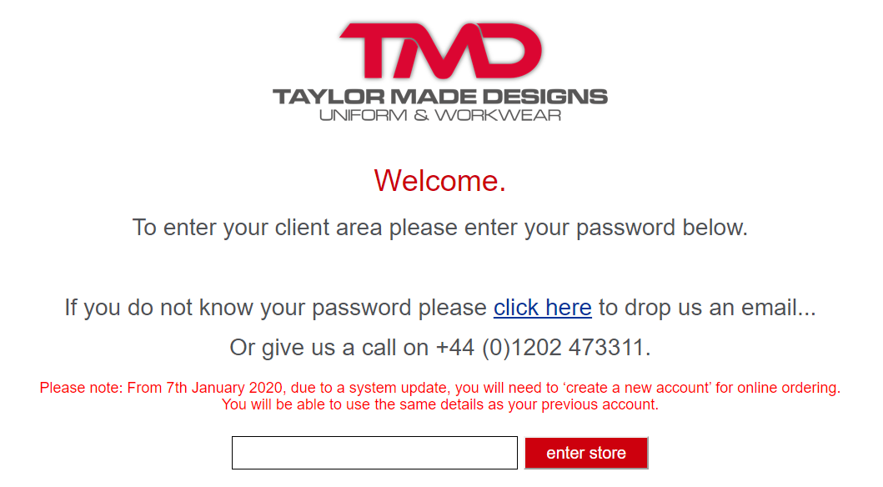

- Entre the password OutcomesPayments and Click the ‘enter store’ tab

- You will now need to create your own account by clicking on the ‘Your Account’ and select new account.

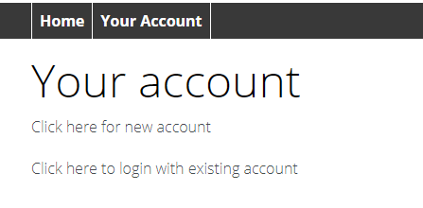

- Complete on sections with your details and address.
- You will then be asked to log back into your new account.

You are now free to browse your e-store and make your selections.

The Armley Grange Uniform can be found under the following tabs:

- Hoodies - for zip up hoodies
- Polo Shirts
- Kids Sports Wear – for Children’s PE shorts
- Sweatshirt – for jumpers
- T-Shirts – for PE t-shirts

Child Size:
UC103 Children’s polo – White or Pale Blue
JH050B Kids Zoodie – Navy
UC202 Children’s Sweatshirt – Navy

PE
SS12B Kids original T-shirt – Navy
JC080B Kids cool shorts – Navy

Adult Size:
UC101 Classic Pique Polo – White or Pale Blue
UC203 Classic Sweat – French Navy
UC504 Classic Full Zip Hooded Sweat – Navy

PE
UC301 Classic T-Shirt – French Navy

- Select the uniform by adding the size, colour, and amount. Then Add to Cart.
- On checkout you can add
- PO number in the order reference if required.
- Notes section for further delivery details or other information you may need to tell us.
- Delivery address.

- Please remember to save you address so the system can remember this for next time.

- Be sure to click the ‘Terms and Conditions’ and then click ‘Place Order’.

- You will then see a confirmation of your order and the order number.

- You will also receive a confirmation email of your order.

- We will process your order and arrange delivery with 10-15 working days.

If you have any queries or problems, please, please don’t hesitate to contact us on the following number: - 01202 473311.

Or email your account manager: lucy.squire@taylormadedesigns.co.uk

Please remember to have you order reference on hand.

Thank you.

